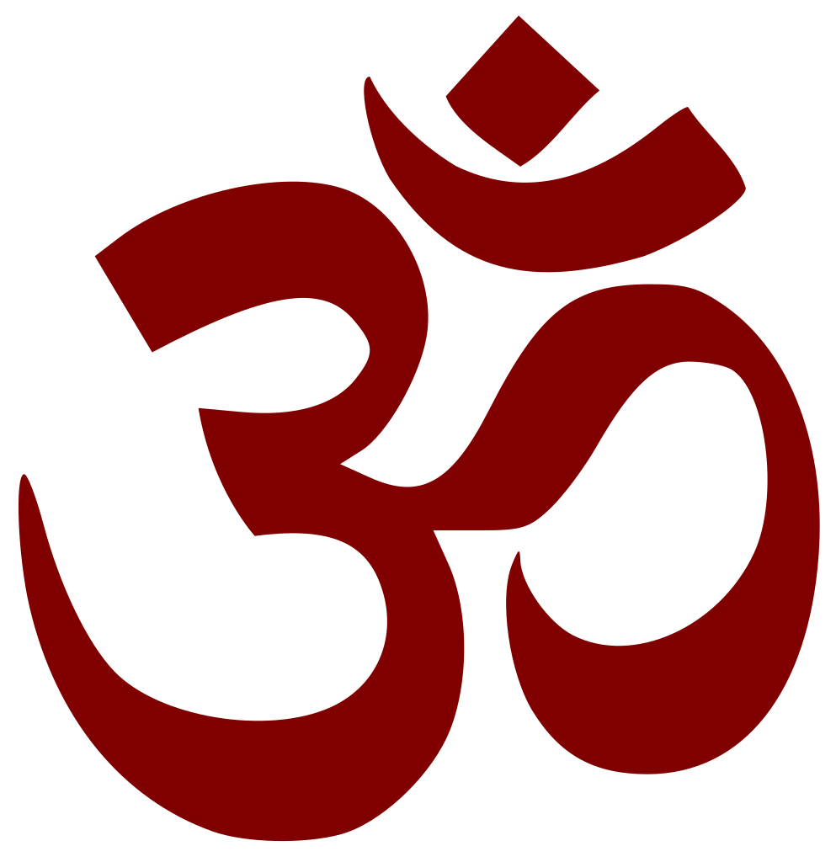

**The 5 Points of Yoga**

**1. Proper exercise** - ***Asanas***

**2. Proper breathing**- ***Pranayama***

**3. Proper relaxation**- ***Savasana***

**4. Proper Diet**- ***Vegetarian***

**5. Positive Thinking and Meditation**- ***Vedanta and Dhyana***

1. **Proper Exercise: Asana**

* Asanas work on the internal machinery of the body, the glands and organs, as well as the muscles.
* They affect the deeper and more subtle parts of the body. The internal organs receive a massage and stimulation through the various movements of the Asanas, and are toned into more efficient functioning.
* Hand in hand with the practice of Yoga postures, we practise deep breathing and concentration of mind. Performed slowly and consciously, the Asanas go far beyond the mere physical benefits, becoming mental exercises in concentration and meditation.

1. **Proper Breathing: Pranayama**

Most people are using only a fraction of their potential lung capacity when breathing. They breathe shallowly, barely expanding their rib cage.

* Yogic breathing teaches one to use the full capacity of the lungs by introducing the full Yogic breath which consists of 3 parts; abdomen, ribs and upper part of the lungs and therefore utilizing the entire lung capacity.
* Once the full Yogic breath is established, one can begin the practice of Pranayama.
* Yogic breathing exercises are called Pranayama which means to control the Prana or subtle energy which in turn leads to control of the mind.
* The grossest manifestation of Prana in the human body is the motion of the lungs. Pranayama begins by controlling the motion of the lungs, by which Prana is controlled.

When we are able to do this, the whole body will be under our control.

* All diseases of the body can be destroyed at the root by controlling and regulating the Prana; this is the secret knowledge of healing.
* The person who has abundant pranic energy radiates vitality and strength; this can be felt by all who come into contact with him or her.

1. **Proper Relaxation- Savasana**

Much of the body’s energy is wasted uselessly. More of our energy is spent in keeping the muscles in continual readiness for work than is actual useful work done. In order to regulate and balance the work of the body and mind, it is best to learn to economise the energy produced by our body. This may be done by learning to relax.

There are three levels of relaxation practiced by Yogis:

* Physical relaxation: where the mind sends messages of relaxation to the different body parts starting with the feet and slowly moving up to the head and eventually moving to the internal organs and systems of the body.
* Mental relaxation: using slow and reathmical breath to calm and steady the mind.
* Spiritual relaxation: this is the most difficult level, which takes much practice. By learning to shift the identification with the body and mind to the innermost Self or Consciousness, the practitioner can enjoy true relaxation free of fear, sorrows and anxieties. We tune to this by asserting the real nature, that is “I am that Pure Consciousness or Self”. This identification with the Self completes the process of relaxation.

1. **Proper Diet: Vegetarian**

The Yogic diet is a lacto-vegetarian one, consisting of pure, simple and natural foods that are preferably organic and which are easily digested and promote health. It is best if we understand that the purpose of eating is to supply our being with the life-force, or Prana, the vital life energy.

* The food we eat has a direct effect on the mind and astral body, and so the greatest nutritional plan for the Yoga student is the simple diet of natural fresh foods that are not overly stimulating to the mind.
* The Yogic diet will help you to attain a high standard of health, keen intellect and serenity of mind.

1. **Positive Thinking and Meditation: Vedanta and Dhyana**

When the surface of the lake is still, one can see to the bottom very clearly. This is impossible when the surface is agitated by waves. In the same way, when the mind is still, with no thoughts or desires, you can see the ‘Self’. This is called Yoga.

* We can control the mental agitation by concentrating the mind either internally or externally. When taking up an activity where mental concentration is essential for success, all other thoughts are slowed down or stilled, and one feels happy. The happiness we experience comes because the mind has been concentrated. At that time, all the worries and troubles of the world disappeared.
* The mental ability to concentrate is inherent to all; it is not extraordinary or mysterious.
* The only difference between this and meditation, is that generally we have learned to focus the mind externally on objects.
* By turning the mind’s concentration inward, upon the Self, we can deepen that experience of perfect concentration. This is the state of meditation.
* On a physical level, meditation brings about prolonged positive state of mind, it rejuvenates body cells and retards decay